TIME SERIES DATA ANALYSIS AND FORECAST METHODS

Lecture 3
Time series classification and properties estimation with spectral and statistical methods

Yekaterinburg
2017
Contents

Lecture purpose 3

Lecture map 3

Part 1. Spectrum analysis of stationary time series 4

Part 2. Nyquist–Shannon sampling theorem 6

Part 3. Partial conclusions 7

Part 4. Statistical hypothesis testing 8

Part 5. Statistical hypothesis testing and criteria for time series 12
5.1. Test for anomalous observations 12
5.2. t-Student test 13
5.3. Fisher F-test 15
5.4. Run Test 16

Part 6. Testing the null hypothesis for stationarity 17
6.1. Test for stationarity based on F-test and t-Student test 17
6.2. KPSS-test for trend-stationary time series 18

Part 7. Quality and goodness of fit tests for time series 21
7.1. Test of residual series mean 21
7.2. Test оf residual data for randomness 22
References 24

Lecture purpose
The purpose of this lecture is to introduce students to the statistical hypotheses, statistical tests and criteria, to study the methods of stationarity tests, and to form the abilities to use the spectrum analysis, Nyquist-Shannon sampling theorem and practical statistical tests.

Lecture map

- Definition of periodogram
- Specific character of Nyquist–Shannon sampling theorem in time series data analysis
- Spectrum analysis
- Statistical hypothesis testing, general algorithm
- Some useful statistical tests for time series
- Testing the null hypothesis of stationarity

Part 1. Spectrum analysis of stationary time series
Autocorrelation function as it was shown earlier, gives only an initial assessment of character for initial TS. When analysis comes about such concept as “frequency” of process, what first comes to mind is, undoubtedly, the Fourier transform. Methods and characteristics of TS, received by the Fourier transform basis, carry the name of spectral evaluation methods of TS characteristics.
The main idea of spectrum analysis is the assumption that the initial time series is stationary in a broad sense (otherwise communication between a selective range and assessment of autocorrelation is broken) and at the same time a row consists of harmonics of different frequencies. The main implementation of this idea is the periodogram allowing to evaluate the power spectrum density (PSD) of a selective signal at which TS acts initial. By determination, the periodogram is Fourier transform of sample autocorrelation function. That is the periodogram is the same assessment of autocorrelation function but presented not in the form of dependence on a delay/lag, but in the form of its frequency representation, thus for search of frequency and harmonics will be a more convenient approach.
In a strict form, the periodogram is calculated through expression:
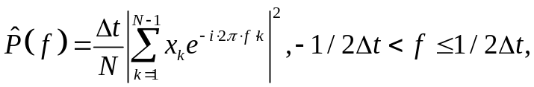 (3.1)
where 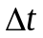 – an interval of a temporary grid of TS (segment between temporary counting, sampling interval), N – number of samples, 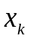 – k-observation of time series data, frequency f is limited by Nyquist-Shannon theorem.
Except a periodogram there are still huge numbers of similar appraisal remedies of spectral power of selection of TS: modifications of periodogram using averaging and window convolution, a method average Bartlett periodogram, Welch method, Thompson's Multitaper-method and other nonparametric methods. Each of these methods has own advantages and shortcomings, but all of them have two common problems: existence of so-called spectral leaks and presence of the fixed frequency resolution.
Spectral leaks are expressed in that real analyzed TS always has the final length of a time frame that will surely be reflected in spectral assessment in the form of convolution with some limited window. In the simplest case (for example, for a harmonious sinusoid), all functions expected the delta will be replaced with their sinc-approximations, that is, the evaluation range as if “flows away” from center frequency.
The fixed frequency permission is connected with the fact that for TS with a final time frame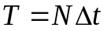, for separation of two close frequencies 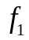 and 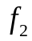 the condition has to be satisfied
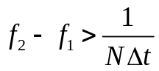, (3.2)
that is minimum possible scale of determination of frequencies is fixed and depending on length of TS. In practice often TS contains periodic and seasonal components which turn out not multiple to this frequency permission that leads to washing out of the received assessment of spectral power. In the simplest case, for example, again for a harmonious sinusoid at which fundamental frequency appears not to the multiple normalized frequency of sampling instead of one pica on a periodogram we will observe whole two, close to theoretical value.
Thus, in practice because of similar problems in the analysis of TS the periodogram and other nonparametric methods are used only for primary assessment of model of TS and its frequency characteristics.

Part 2. Nyquist–Shannon sampling theorem
As for Nyquist–Shannon sampling theorem, in relation to the analysis of TS, its sense and application addresses in the opposite direction. Let's remind that according to Nyquist–Shannon theorem, continuous implementation of a signal can be recovered on its time series unambiguously if spectral content of implementation is limited also the maximum frequency in an implementation range less or it is equal to Nyquist frequency, that is 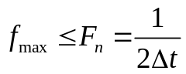. For the analysis of TS required rather values of the periods and functions from time. Let's invert expression with a Nyquist frequency and we will express it through temporary discrete steps:
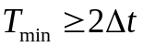 (3.3)
where - sampling interval, 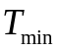 - minimal recovered period of modes. It turns out that for the fixed sampling interval (and for TS it indeed, the sampling interval is in advance known and fixed), the minimum period which can be noticed has to be, at least, two times are more than sampling interval. For average monthly numbers it is impossible to find cycles of a month, for daily – cycles length an hour and a half, etc. You should not forget as well about the fixed frequency resolution (3.2) which (transferred to the periods) speaks about that, what will be impossible to divide seasonal and cyclic components with periods difference between which is less than recovered minimum period . In practice such close periods are estimated to the same cycle, but consider that it has a floating period. For more exact result use already adaptive means of the analysis of TS which allow building dependences of the period of cycles on a present situation of time on the set interval of time.

Part 3. Partial conclusions
Methods of creation of assessment for sample autocorrelation function and periodograms / estimates of a window are rather similar in character (and some of these estimates are even equivalent). Therefore both benefits and shortcomings of them are very similar. Differences in them, in fact, are in their visualization therefore these methods are used together: what is bad considerably in one method can be more obviously expressed in another.
Receiving selective estimates of autocorrelation function and range is nonstructural (that is nonparametric) the approaches similar to representation of empirical function by the histogram. Both of these approaches only focus attention on that, as is so noticeable in initial TS therefore they serve only as the first step in the analysis of TS. With respect thereto, often these two approaches use not so much for the analysis of ranks how many for assessment of its initial characteristics which then are used for identification of models and search of those parametrical methods which for given TS will be the most effective.
Also, as a result of the reasoning given above, it is important to understand, that all initial estimates of statistical properties, beginning even about an expectation value, rely on the fact that the TS is supposed to be stationary. If a data is non-stationary, then all estimates, both autocorrelation, and spectrum, lose the meaning. Therefore, if the TS was defined as non-stationary, any of the listed above approaches will be, formally, not applicable. Discrete expressions can be used, but for NSTS they will serve as something it seems “average temperature in hospital”. For this reason for the analysis of NSTS use adaptive methods of the analysis, and all main characteristics of NSTS are calculated not in the form of single estimates, and in the form of full-fledged and functions from time, and from other parameters (shift, etc.) at the same time.

Part 4. Statistical hypothesis testing
Any preliminary analysis of TS relies on two fundamental necessary assessments: it is to check the TS on stationarity and to search a type of model, the most suitable for this data. Both that and other factor rely on checks of statistical hypotheses. For check of these made hypotheses use the so-called mechanism statistical criterions or tests. Before passing to implementations of these methods, at first briefly we will remember in how to check them and to apply the statistical hypotheses in general.
It is known that any TS is only a private selection of some accidental process. And it means that any statements told about character and properties of the set row are not absolutely reliable, and can only be evaluated with some reliability. In statistics the similar concept is called more strict concept of statistical certainty of the tested phenomenon. Some value is called statistically significant if the probability of accidental emergence of this value or the phenomena generated by it tends to zero or is extremely small. It is what just and is necessary for us in the analysis of TS – to consider the received characteristics and judgments of a type of a row statistically significant. For making decision on statistical certainty of this or that phenomenon use a concept of statistical hypotheses.
Statistical hypothesis – the probabilistic assumption for a type of distribution and properties of a stochastic variable , which can be confirmed or disproved by applying the statistical techniques to this sample. It is necessary to understand that at the same time the hypothesis assumes some statement to which it is possible to respond unambiguously either it is only positive, or it is only negative, that is, roughly speaking, only “yes” or “no”, the third option should not exist. The initial hypothesis then is considered a direct or null hypothesis of H₀, and the answer opposite to it – the reverse, the alternative or competing H₁ hypothesis. As soon as this unambiguous statement is formulated rather some stochastic variable, the hypothesis becomes statistical.
Statistical hypotheses can be several types. The statistical hypothesis is called simple if it allows defining unambiguously distribution and its properties to which this stochastic variable belongs. If the hypothesis sets only belonging of an stochastic variable to some family of distributions (that is consists of some set of simple hypotheses), then such hypothesis is considered complex.
The made hypothesis is checked by means of a statistical criterion or the test – that is on the basis of some mathematical rule or the built function which serves as a measure of identification of discrepancy between expected by a statistics/indicator and empirical. In stronger sense, the statistical criterion sets unambiguous compliance between random check from unknown distribution and possible hypotheses (zero and alternative). Statistical criterions can also be parametrical in which statistical parameters of initial selection are calculated (expectation value and variance, for example), and nonparametric which do not make calculation of parameters and rely only on calculation of a data.
When checking statistical hypotheses as they are the probabilistic phenomena, there can also be errors. These errors are divided into two enough similar a class: errors of first kind, in which the correct null hypothesis is rejected, and error of second kind, in which the incorrect hypothesis is accepted. Probability of an error of first kind is called a significance level α and also is an important parameter for statistical tests.
Now there is the huge quantity of statistical hypotheses as the mechanism of their work is rather universal and allows to evaluate very effectively these or those classes of time series, their models, properties of TS, etc. The general algorithm of check of statistical hypotheses is as follows to the simplified algorithm:
- The statistical null hypothesis 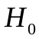 and on its basis is formulated alternative hypothesis 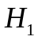.
- The significance level , on which depends whether will be the null hypothesis accepted or rejected for benefit of alternative.
- Some statistical criterion k is calculated. This value k is calculated on the basis of this selection of accidental process (that is on the basis of counting of TS) and, in essence, is some stochastic variable which has to submit to the expected distribution law (depending on a hypothesis).
- This estimated criterion then is compared to the known critical value of criterion a priori, that is there is a check whether there is a found criterion a critical region of C, or remains within regulation 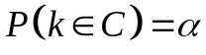.
- At hit of a statistical criterion in a critical region, the null hypothesis is rejected (and alternative is accepted), when missing – the made hypothesis is accepted.
The flowchart of an algorithm of statistical test is submitted to abbreviated form in the figure 3.1.
Further we will consider several statistical tests, which will be useful to us in the analysis of TS. Also special role will be played for the statistical criterions allowing to evaluate stationarity of TS.
Define
and
Define significance level
Estimate the statistical criteria
yes
?
Reject
Accept

Accept
no
Figure 3.1 – Flowchart of an algorithm of statistical test

Part 5. Statistical hypothesis testing and criteria for time series
Let's begin consideration of statistical hypotheses with the simplest example. It is also necessary to remember that all of them make a start from the assumption of stationarity of TS as often rely on estimates of expectation value and variance in the form of the values which are not depending on a shift/lag (that is from stationarity in a wide sense). The statistical criterions which are directly engaged in check of TS on stationarity will be brought at the end. Such order of definition of criteria is selected because all statistical tests which are engaged in check of TS on stationarity have more complex structure for studying, and it is always better to begin, as we know, with simpler and clear examples.

5.1. Test for anomalous observations
Here we use Irvine's method. For all observations of TS the following hypotheses – : i-observation is not anomalous or abnormal, : i-observation is anomalous or abnormal. To test this hypothesis we will calculate criterion:
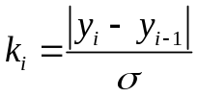 (3.4)
where 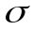– standard root mean square deviation: 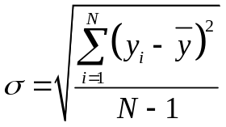,
N – number of samples or length of TS, 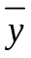– expectation value.
If value 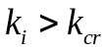, then with probability hypothesis is rejected and the alternative hypothesis is accepted , that 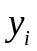 is an abnormal observation. Value 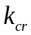 depends on the number о samples and the level of . Some of these values are presented in table 3.1.

Table 3.1. Critical values for Irvine's method
N | 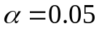 | 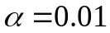
10 | 1.5 | 2.0
20 | 1.3 | 1.8
50 | 1.1 | 1.6
100 | 1.0 | 1.5
400 | 0.9 | 1.3

For example, we have a time series with 10 samples:
[100, 143, 124, 115, 113, 110, 105, 100, 104, 105].
To consider even one о them an anomalous observation, we need 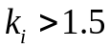 at . After use of a formula (3.4) we receive that 2 and 3 elements can be considered abnormal. Therefore, with probability of an error of first kind 0.05, it is possible to accept alternate hypothesis about, that the 2 and 3 counting set by TS are abnormal observations. As we see, all algorithm of check of this statistical hypothesis works in full accordance with the general algorithm of accomplishment of statistical tests given on fig. 3.1.

5.2. t-Student test
At creation of additive model of TS (see lecture 1), it is important to know precisely whether we will be able to select in general separately determined part and separately accidental. By default we somehow considered that both of these parts exist always – one describes systematic properties of initial process, another describes arbitrary factors. In practice analyzed by TS can in the principle be selection of purely accidental process with unknown distribution. The most simple hypotheses on existence of nonrandom components in TS in fact check constancy of mean value. Therefore statistical hypothesis will look as follows – 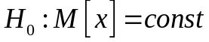, 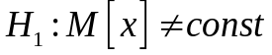. As we will see further, having added to hypotheses also the requirement about constancy of dispersion, it will be possible to try to check TS and for stationarity in a broad sense. In general, this hypothesis can be checked different statistical tests (painfully widely they are defined). We use two simplest and widespread methods here.
Let's break initial TS into two selections, approximately equal on number of counting. If averages of these private selections differ, means at TS there can be some trend (tendency) which is not random by default.
Letr the first part of TS be 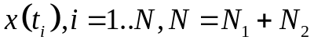 from 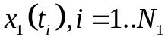, and the second part – 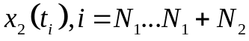. Let's estimate their expectation value and variance 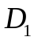 and 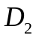 (see eq. 2.7 and 2.8). Let's find a t-Student criteria:

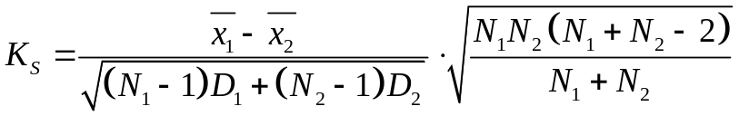 (3.5)

If inequality 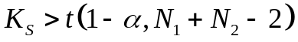is true, then the hypothesis about constant expectation (mean) value is rejected with significance level of .
The student criterion has an essential shortcoming – in order to use it it is initially supposed that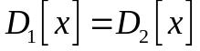, that is dispersions of both parts are identical, i.e. throughout all selection of TS its dispersion does not change significantly. In practice it is carried out not always. At least, it is desirable to be convinced at first then that a condition will be carried out. And how it can be made? Well, of course to put forward this equality in a statistical hypothesis and to use some statistical criterion for its acceptance or acceptance of alternate hypothesis. Such statistical criterion is an F-test.

5.3. Fisher F-test
So, we want to be convinced that both parts of a row have identical dispersions 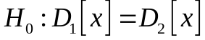. In other words, these two TS is private selections of the same stochastic variable. Then it is possible to use well-known criterion of Fischer:
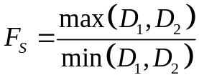 (3.6)
where 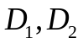 – estimates of dispersion of these two TS from one private selection (in our case, it were two approximately equal parts of the same TS). If inequality:
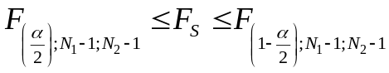 (3.7)
is no carried out, then the hypothesis of constancy of dispersion is rejected with significance level. To similarly previous cases, critical values 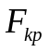 are determined most often by tables of criterion of Fischer, or through calculations of specialized mathematical functions. In this table parameters are significance level, and number of degrees of freedom 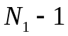 and 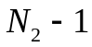.
Thus, we will apply at first Fischer's criterion and, having set equality of dispersions of two parts, then we will apply a student criterion, we can accept or reject a hypothesis of existence of a trend (or other nonrandom component) in analyzed by TS.

5.4. Run Test
From initial time series 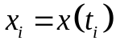 let's create a new variational series, arranged in increasing order:
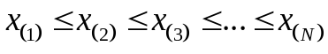 . (3.8)
Let's determine a selective median of this row by a formula:
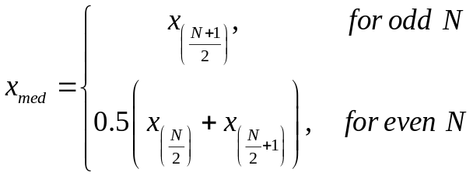 (3.9)
Now we are returned to initial TS and we create a series of «+» and «–» on its basis. To the sample 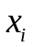 we denote «+», if 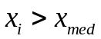, and «–», if 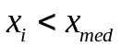. If 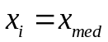, then such points are not considered. At us series in a row of the going pluses and minuses will turn out. We are interested in total number of such ν series and extent of the longest of them .
If the studied row consists of independent observations (the hypothesis of an invariance of mean is right ), then the alteration between «+» and «–» must be random, that is them it will be approximately identical by quantity, and they will be close by the size.
Then the statistical criterion will be the following: if at least one of inequalities (3.10) it is broken, a hypothesis about an invariance of mean is rejected with probability of the error α.
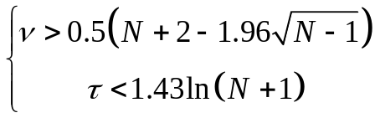 (3.10)-(3.11)
It means, that we accept an alternative hypothesis of , that is in analyzed TS there is some time-dependent nonrandom component.

Part 6. Testing the null hypothesis for stationarity
So, we got acquainted with basic statistical criterions, which allow to evaluate characteristics and properties of TS. All of them as it is possible to notice rely on the assumption that the studied row is stationary. Therefore before using them, to describe mathematical models of TS and to run for search of a cycle and seasons, it would be quite good to carry out an inspection of TS on stationarity.
As it was shown in the first lecture, theoretical determination stationary TS even in a broad sense is rather difficult for practical application. With respect thereto in practice use well fulfilled mechanism of check of statistical hypotheses. There will be several such statistical tests of check of TS for stationarity.

6.1. Test for stationarity based on F-test and t-Student test
This statistical test consists of two parts: at first Fischer (3.6) criterion for check of a hypothesis of constancy of dispersions is used 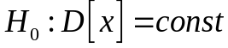, and then if the hypothesis is accepted, we check a student criterion (3.5) a hypothesis of constancy of averages . If both hypotheses are accepted then also the composite hypothesis about stationarity of TS is accepted. To the techniques which are similarly described above, initial it is necessary to segment TS two approximately equal on number of counting, to consider each part for separate selection of one accidental process.
This statistical test is based on stationarity determination in a broad sense where independence of time of mean and variance is just required. But this test has essential shortcomings. First оf all, by stationarity determination in a broad sense, we will need to touch all possible shifts in TS, and for each of them estimate the mean and variance to be constant. Thus, it is strict by determination, we have to break initial TS not into two parts, and into many parts of small length, and then in pairs to check for them Fischer and t-Student's statistical criterions. It is clear, that with growth of number of counting, this work will be too bulky. Therefore are limited to comparison only of two parts, but reliability of determination of property of stationarity of it then remains to TS weak. Secondly, both of these criteria are theoretically described and accurately formulated for normal distribution. This condition most often, naturally, is not satisfied in practice, so, the received estimates of truthfulness of hypotheses are extremely approximate and doubtful.
In general it turns out that the alternative tests allowing to evaluate TS on stationarity or non-stationarity are necessary.

6.2. KPSS-test for trend-stationary time series
Absolutely another approach to the analysis of stationarity observed by TS uses the so-called statistical test from 1992 of an origin of Kwiatkowski–Phillips–Schmidt–Shin, further just the KPSS-test.
This statistical criterion initially makes a start from structural additive model of TS in shape
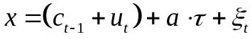 (3.12)
where – initial time series, 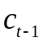 – constant mean, 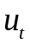 – independent stochastic variable from the same distribution, as 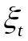, but with expectation value of 0 and variance оf 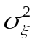, – trend, – some stationary process.
There are two hypotheses – 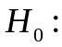time series is stationary (thus 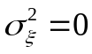), 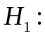time series is non-stationary (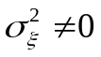). With this definition instead of the theoretical description of a concept of stationarity in a broad sense as we see, the test becomes more clear and concretized. The criterion of statistics is calculated according to:
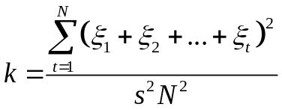 (3.13)
where  – number оf samples, s – standard error in from of Newey-West long-run variance, – samples from stationary process.
Apparently from (3.13), the criterion estimation is very difficult therefore at the majority of modern mathematical and statistical packets function of calculation of this criterion (or the KPSS-test at once) is present.
The criterion k then is compared to critical known value, and the null hypothesis about stationarity of TS or is accepted with α significance level, or is rejected, that is a row is considered NSTS.
From where there was an idea of this statistical test in general and what expression is based (3.12) on? The idea of check on stationarity lies in the known large subsets stationary TS is a trend-stationary series (3.12) and differential stationary series (3.12 at a=0). Both of these processes operate with that assumption that though initial TS can be non-stationary, its first difference (that is 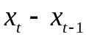) can be stationary. In the theory of differential schemes this fact can be determined check on single roots (unit root). The concept of unit roots is connected with a characteristic polynomial of autoregressive models. It turns out that if all roots of this polynomial it appears out of a unit disk (on the module more unit), then such process will always be stationary. If several roots of a polynomial are equal on the module to unit, that stationarity is still achievable through differential schemes. Existence of unit roots corresponds to non-stationarity of initial process.
It turns out that theoretically wide problem of establishment of property of stationarity or not stationarity of TS can be reduced to more strict mathematical problem of search of roots of a characteristic polynomial. For the first time the similar technique of check on stationarity on the basis of single roots was thought up by David Dickie and Wayne Fuller in 1979. Their statistical test was called the test Dickie-Fuller (DF test). Then the whole family of similar statistical checks of unit root appeared: ADF test, Phillips Platform test, Leyburn's test, etc. Among them the KPSS test is selected first of all with the fact that it is directed to a concept of stationarity, but not for a concept of single roots of a polynomial, that is saves researchers of TS from transition from concepts of autoregressive to the determination of stationarity of TS.
The technique of ADF tests so was effective in practice, that in 2003 for its use in the analysis of economic ranks Clive Grendzher received the Nobel prize on economy. Nevertheless, it is necessary to understand that the KPSS test all the same is a statistical criterion, and means, and it has restrictions and shortcomings. First, this test checks not all set of roots (which can be very much), and only their small number. Therefore much better the KPSS test is suitable for determination of the fact of non-stationarity of TS. Really, if at least one of these characteristic roots lies in a unit disk, then the hypothesis is rejected at once and a row will be NVR. Secondly, there can be a case when all estimated roots on the module are equal to unit (will be single), and then there is an uncertainty in the form of model, and KPSS-test then will only indicate that stationarity of a row can be, but additional checks are necessary. In general, the KPSS test for the present is one of the best and effective remedies of check of TS on stationarity.

Part 7. Quality and goodness of fit tests for time series
Let's assume that one of methods to us managed to construct model for stationary TS. It appears, it is possible to evaluate its adequacy and quality too using the device of application of statistical criterions. Input data for such check is always a number of a remaining errors (discrepancies), that is a difference between initial TS and its determined model:
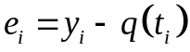. (3.14)
In the determined component 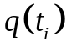 can be, as well as a trend, and any other trigonometrical or similar components.

7.1. Test of residual series mean
For correctly constructed model, a number of a remaining balance has to have the expectation value close to zero. Really, if it not so, then we did not consider any determined part (the same trend, for example) in model. We formulate the following statistical hypotheses:
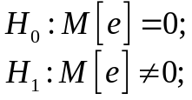. (3.15)
If hypothesis accepted, then 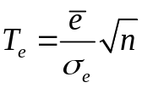 submits to Student's distribution with N-1 degrees оf freedom. Thus, if the calculated value of criterion appears more than a critical value of a student criterion 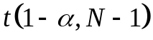, then the hypothesis is rejected with a significance level . It means that the selected determined part contains something nonzero and systematic.

7.2. Test оf residual data for randomness
At creation of initial additive model stationary TS, it was supposed that its accidental component is some aleatory variable. If separation of the determined and accidental parts in the analysis of TS was rather qualitative, then a number of a remaining balance (3.14) has to be just a set of aleatory variables. For check of this hypothesis in the simplest case the criterion of "rotary points" is used. The point 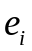 is called rotary, if conditions are satisfied:
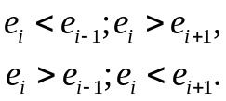 (3.16)
If a number of a remaining balance is accidental, then one rotary point on average is the share of 1.5 counting. Let these points there will be Ne. Then statistical verification of this assumption will look so: if inequality is carried out:
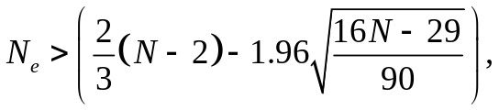 (3.17)
then a number of a remaining balance can be considered random.
Even more strict check is connected with the fact that a number of a remaining balance is supposed an aleatory variable with normal distribution. In this assumption there is a huge number of benefits, the most important of which is a high quality of the received model as then there are correct all statistical and correlation approximations and estimates. Check of a number of a remaining balance on its normality is usually made by means of Kolmogorov-Smirnov criterion.
The classical criterion of KS-test is intended for check of simple hypotheses about selection accessory to some completely known distribution of an aleatory variable. We are interested in its modification which allows to check complex hypothesis about selection belongings to some distribution which parameters are determined by the most this selection. The hypothesis is rejected if statistics 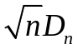 exceeds a quantile of distribution 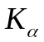 at the set α significance level, and is accepted in the return case.
Kolmogorov's distribution is described in a type:
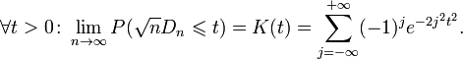
In practice, for use of criterion of Kolmogorov-Smirnov specialized functions of mathematical and applied packets which then are compared to table values are used, or display result about acceptance or rejection of a hypothesis at once. The detailed technique of use of criterion of Kolmogorov-Smirnov is given in references below.

References

- Katsuo Tanaka. Time Series Analysis: Nonstationary and Noninvertible Distribution Theory. — Wiley Series in Probability and Statistics, 2nd ed. — 2016. — 960 p.

- Kwiatkowski D., Phillips P. B., Schmidt P., Shin Y. Testing the null hypothesis of stationarity against the alternative of a unit root // Journal of Econometrics, 1992. — Vol. 54. — pp. 159–178.

- Dickey D. A., Fuller W. A. Distribution of the Estimators for Autoregressive Time Series With a Unit Root // Journal of the American Stat. Association, 1979. — Vol. 74. — pp. 427–431.

- Daniel, Wayne W. (1990). Kolmogorov–Smirnov one-sample test. Applied Nonparametric Statistics (2nd ed.). Boston: PWS-Kent. pp. 319–330. ISBN 0-534-91976-6.

